Answer 20 Mission-Critical Questions to Define Your Brand

1. Describe your operations and lines of business.
2. Explain your brand in a short phrase you can deliver in 60 seconds.
3. What is your company tagline?
4. What are your website keywords?
5. Do you want to stick with your present logo and corporate identity?
6. What industry problems/customer pain points does your company solve?
7. What type of brand program have you had in place to date?
8. What emerging and/or popular trend(s) does your company address?
9. What is your current market position and ideal future market share?
10. Describe your target customer(s).
11. How do your current customers and employees view your brand?
12. What do your customers value most about what your company offers?
13. Identify three to five unique differentiators/strengths of your company.
14. Who are your competitors?
15. If your company were a person, how would you describe it?
16. What do you want your company to be known for in the industry?
17. What are your company’s business goals?
18. What benefits do your company products/solutions bring to the market?
19. Describe your current go-to-market strategy.
20. Describe your marketing communications/content marketing program.

Brand Strategy Phase 1—Define & Assess
• Research/Audit
• Conduct data gathering (interviews, emails, or workshops)
• Distribute questionnaires
• Define target audience
• Identify revenue and market share goals
• Obtain competitive intelligence
• Review existing materials
• Explore industry and associations
• Identify company touch points

Brand Strategy Phase 2—Strategic Planning
• Holistic Branding Strategy
• Internal (build pride and involvement for employees)
• External (build buzz and credibility for customers and prospects)
• Messaging Development
• Vision/Mission/Values
• Value Proposition
• Go-to-Market Strategy
• Brand Personality/Positioning/Identity/Architecture
• Tagline
• Deliver Brand Messaging Platform
• Creative Direction
• Graphic Design and Image Look-and-Feel
• Colour Palette
• Layout
• Establish Company Voice, Tone
• Review Proposed Website (design, functionality, strategy)
• Review Logo Design
• Liaise with Graphics, Website, Product, and Print Vendors
• Deliver Brand Brief
Brand Strategy Phase 3—Creative Approach
• Corporate Identity System (e.g., logo design, signage, stationery, business cards,
proposal template, email auto signature, screen saver, cross-departmental branding
such as checks for Finance and forms for HR, etc.)
• Brand and Style Guidelines for all media
• Website with optimized SEO
• Content Development and Management
• Copywriting
• Videos
• Webinars
• Lead Generation
• Content Marketing
• Corporate Brochure
• Product Fact Sheets
• Thought Leadership (Case Studies, White Papers, Perspectives)
• Timeline/Company History Fact Sheet
• Customer Newsletter (digital or print)
• Social Media
• Blog
• Facebook
• Twitter
• LinkedIn
• Pinterest
• Advertising (online and offline)
• Branded Promotional Products
• Sales Toolkit
• Proposal Language
• Elevator Pitch
• Corporate Deck
• Mobile Marketing
• Direct Mail and Email Campaigns
• Public Relations
• Press Kit Elements (digital and print)
• Brand Announcement Card
• Boilerplate Company Statement
• Press Release(s)
• Executive Backgrounder
• FAQs
• Media Contacts
• Client List
• Corporate Folder
• Telling the Brand Story
• Social Media
• Customer Voice, Dialogue and Experience
• By-lined Articles
• Internal Communications
• Brand Email Announcements
• Brand Book (tool that explains the brand)
• Event Marketing
• Exhibit Booth Graphics, Brand Messaging
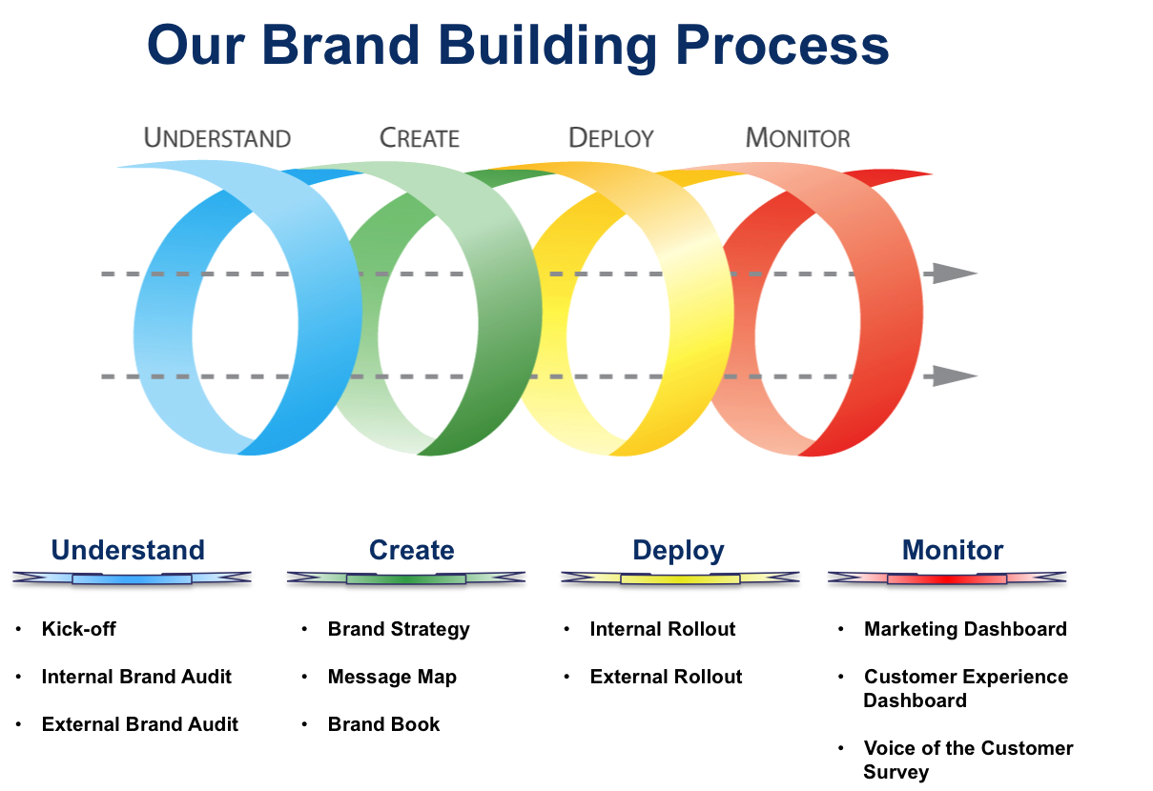

Brand Strategy Phase 4—Execution & Implementation
• Content Development and Copywriting
• Production (digital, print, product)
• Media Plan
• Press Conference Brand Launch (if applicable)
• Newspaper/Magazine Placements
• Radio/TV Media Tours (if applicable)
• Speaking Engagements
• Direct Marketing
• Conferences
• Trade Shows

Brand Strategy Phase 5—Measurement & Analysis
• Brand Asset Management
• Develop measurement tool/dashboard to assess brand awareness and ROBI
from current state to rebranded state
